Grade 7 Accelerated · Unit 6  Unit 6 Review  Relationships in Triangles | Name______________________  Date______________________  Period____________________

Show your work. Circle your final answer.
HOW TO USE THIS. This review covers every learning target of Lessons 1–8 — more than the test does. Work it in parts. If you miss two or more in a part, that part is where to spend your study time. The reference sheet has everything you need for each part. Thread B's two angle days come after the test and are not on it.
PART A. The Triangle Inequality and the Converse Lessons 1–2 · 4 questions
1. Can the three lengths be the sides of a triangle? Show the test.
a. 5 cm, 9 cm and 15 cm

b. 6 inches, 10 inches and 16 inches

c. 11 m, 4 m and 8 m

2. Two sides of a triangle are 6 ft and 14 ft. Write an inequality for every possible length x of the third side.

3. Is a triangle with these sides a right triangle? Show the test.
a. 65, 33 and 56

b. 7, 8 and 11

4. Select ALL of the sets of side lengths that make a right triangle.
□ A. 6, 7, 8
□ B. 10, 24, 26
□ C. 3, 4, 7
□ D. 8, 9, 12
□ E. 16, 30, 34

PART B. The Pythagorean Theorem Lesson 3 · 6 questions
5. A right triangle has legs of 12 ft and 5 ft. How long is the hypotenuse?

6. A right triangle has legs of 3 inches and 13 inches. How long is the hypotenuse, exactly and to the nearest tenth?

7. A right triangle has a hypotenuse of 85 cm and one leg of 84 cm. How long is the other leg?

8. A right triangle has a hypotenuse of 11 ft and one leg of 8 ft. How long is the other leg, exactly and to the nearest tenth?

9. Which equation can be used to find x?
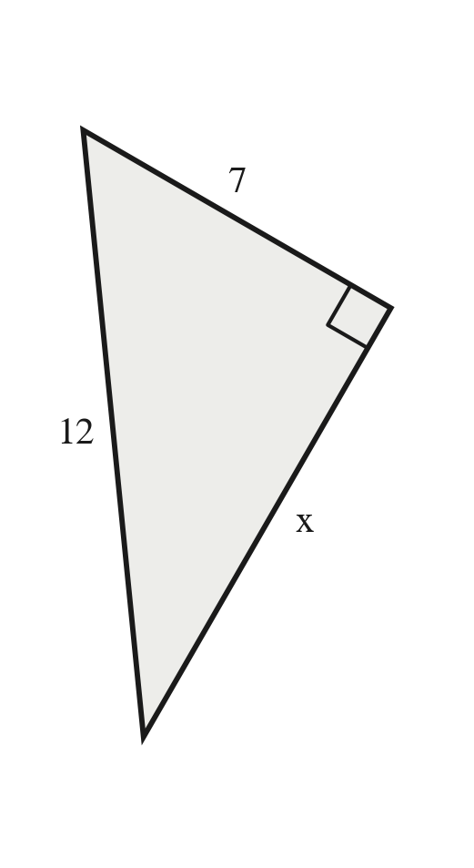
○ A. 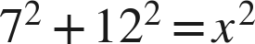
○ B. 
○ C. 
○ D. 

10. Ana finds the missing leg of a right triangle whose hypotenuse is 5 cm and whose other leg is 3 cm. She writes , so the leg is about 5.8 cm. What did she do wrong? Find the leg.

PART C. The Pythagorean Theorem in Real-World Problems Lesson 4 · 5 questions
11. A 10-ft ladder leans against a wall with its foot 6 ft from the wall. How high up the wall does it reach?

12. A rectangular garden is 10 m long and 11 m wide. How long is a path straight across it from corner to corner, to the nearest tenth of a meter?

13. A ramp rises 1 ft over a run of 9 ft along the ground. How long is the ramp, to the nearest tenth of a foot?

14. A park is a rectangle 9 m by 11 m. How much shorter is it to walk straight across the park from corner to corner than to walk along two of its sides? Give the answer to the nearest tenth.

15. A 9-ft ladder stands with its foot 2 ft from a wall. Will it reach a window ledge 8.5 ft up the wall?

PART D. Distance on the Coordinate Plane Lesson 5 · 5 questions
16. Find the distance between the two points.
a. (−6, 2) and (5, 2)

b. (3, −7) and (3, 2)

17. Find the distance between points P and Q.
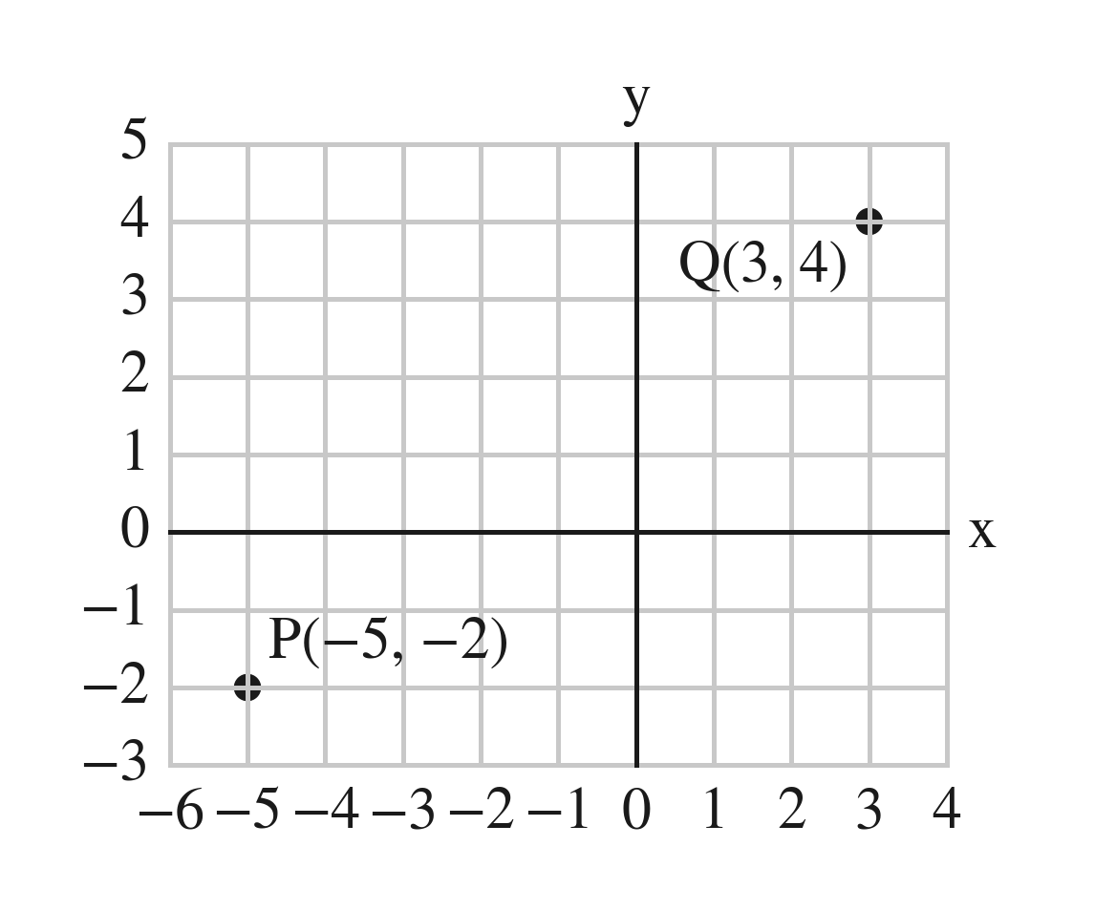

18. Find the distance between (−6, −1) and (1, 5), to the nearest tenth.

19. How far is the point (−1, 6) from the origin? Round your answer to the nearest tenth.

20. What is the distance between (−2, −6) and (−2, 3)?
○ A. 3 units
○ B. 9 units
○ C. 10 units
○ D. −9 units

PART E. Coordinate-Plane Problems and Perimeter Lesson 6 · 4 questions
21. Every part below is about triangle PQR on the grid, with corners P(−4, −4), Q(8, −4) and R(8, 5).
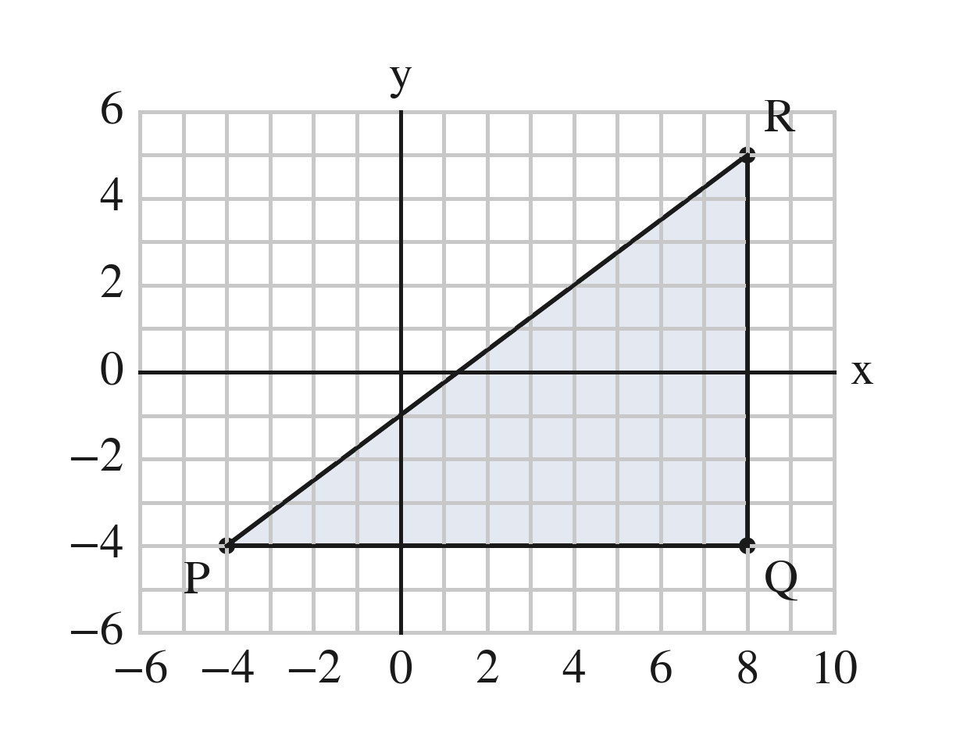
a. Find the length of PQ.

b. Is triangle PQR a right triangle? How do you know?

c. Find the length of PR.

d. A triangle similar to PQR has a shortest side of 3. How long is its longest side?

22. Find the perimeter of the triangle with corners (−4, 2), (6, 2) and (6, −1), to the nearest tenth.

23. On a town map in blocks, the school is at (−2, −4) and the park is at (2, 1).
a. How far is it from the school to the park along the streets?

b. How far is it in a straight line? Round your answer to the nearest tenth.

24. A rectangle has corners (−3, −2), (5, −2), (5, 4) and (−3, 4).
a. Find its perimeter.

b. Find the length of one of its diagonals.

PART F. Similar Triangles and Indirect Measurement Lessons 7–8 · 6 questions
25. Are the two triangles similar? Show the three ratios.
a. Sides 5, 7, 8 and sides 15, 21, 24

b. Sides 5, 8, 10 and sides 10, 16, 18

26. The two triangles are similar. Find x.
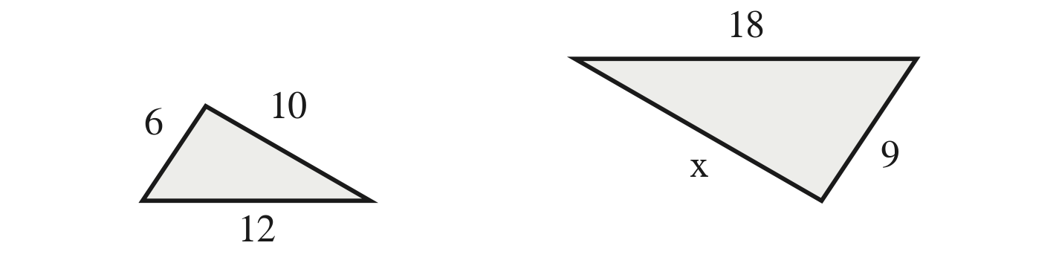

27. A triangle has sides 15, 20 and 30. A similar triangle's middle side is 8. Find its other two sides.

28. A 4-ft fence post casts a 3-ft shadow. At the same moment, a tree casts a 21-ft shadow. How tall is the tree?
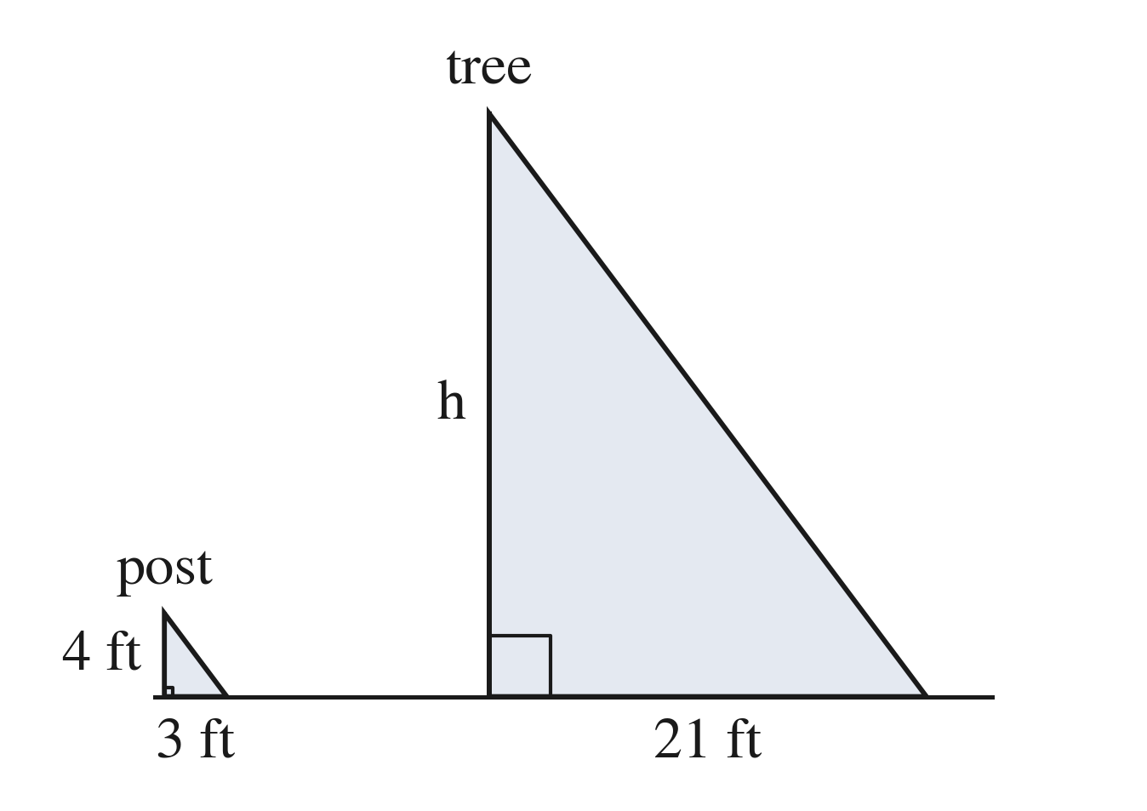

29. Kai's eyes are 5 ft above the ground. He stands 3 ft from a mirror on the ground and sees in it the top of a pole that stands 12 ft beyond the mirror. The two right triangles are similar. How tall is the pole?

30. Which triangle is similar to one with sides 6, 8 and 9?
○ A. 8, 10, 11
○ B. 12, 16, 20
○ C. 9, 12, 13.5
○ D. 6, 8, 12

